PA B2-2: FORMULAS
TOPIC
B2

TIME TO COMPLETE: 1 HOUR

Write your responses to parts 2 and 4 in a word document. Make sure to include your name and the programming assignment number. Your code can be uploaded alongside the accompanying word document.

PART 1: PROBLEM STATEMENT
Doing math is difficult, right? Well, what if we let the computer do the math for us? That sounds nice, right?
I’ve got one big equation on my radar right now – the Quadratic Formula. What can I say? Square roots and I aren’t on speaking terms.
I need you to make a program that will allow the user to provide input for the variables in the quadratic formula. This program shouldn’t crash under ANY circumstances, and it should loop infinitely to allow the user to do as many formulas as they would like.
For the quadratic formula, we need to ensure that the value of a isn’t 0, and that the discriminant is greater than 0.

PART 2: BRAINSTORMING THE ALGORITHM
- What are all the ways that you can think of that a program like this may crash, and how do you plan to address them? [10]

- What will be the general structure of your algorithm for this program? You do not need to write it out in code but explain it in plain English. [10]

- What specific program structures (if statements, loops) do you plan to use in the creation of this program and how? [5]
PART 3: WRITE THE PROGRAM
Write your code in a .py file using no dependencies (using other libraries or programs). Feel free to use the IDE of your preference, but ensure you only upload the .py file (alongside the answers to the questions in this document).
Your program will need to take input for as many words as the user would like to enter. Ensure that your submission adheres to the FIVE LAWS OF CODECRAFT.
Example output is provided below.
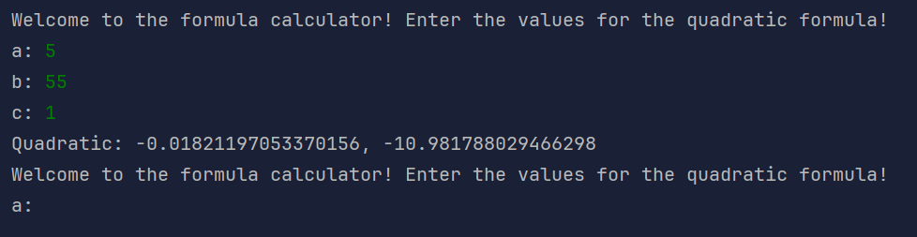
Upload the .py file with your program to ManageBac. [5]
Ensure that your program doesn’t crash under any circumstances [15]
Ensure that your program returns correct values for the equation [15]
Ensure that your program does not terminate after the user does one equation [10]

PART 4: REFLECTION
Answer the following questions in the "Programming Assignment Documentation Template" that can be found in ManageBac.
- Did your final project match up with your idea from the brainstorming phase? If not, what changed? [5]

- Are there any known bugs in your program that you could not address? [5]

- How did you manage the flow of the program? Specifically, how did you allow the user to input multiple equations? [5]

- How did your error detection work? Were you able to catch all cases? [10]

- List any sources used in the creation of your program and how you used them. [5]

